**Assign detach key and Escape sequence to a container**..

1. By using Escape sequence advantage is coming out of the container without disturbing the main process ID…( ctrl p+q )
2. Without ES if we give directly exit command the running process id will be exit..

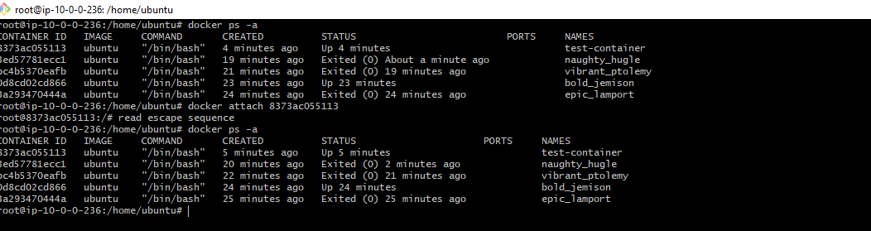

**Map multiple ports numbers for a container…**

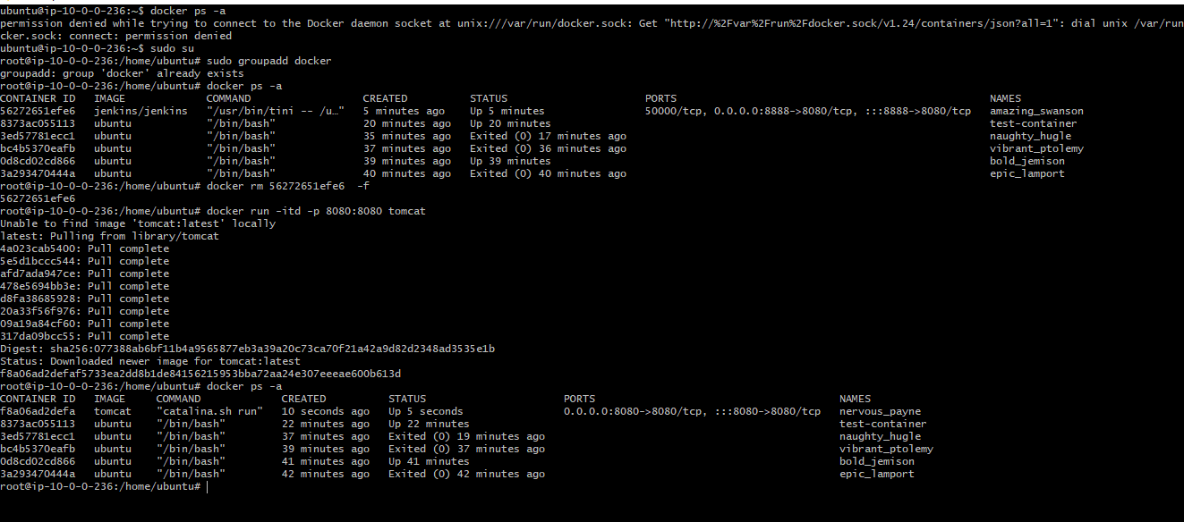

**Docker command to copy files from host machine to a running conatainer…**

1. **Image 1 shows copying url from host machine to source path..**

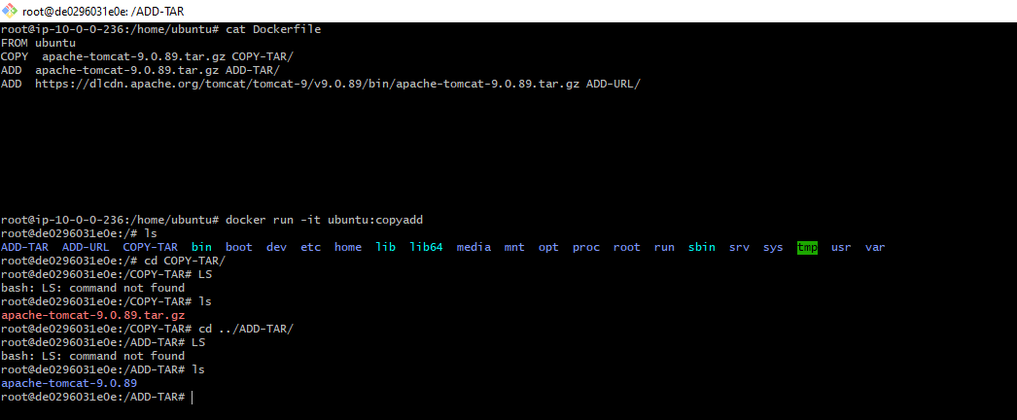

1. **Image 2 shows that copying url from source path to a running container…**

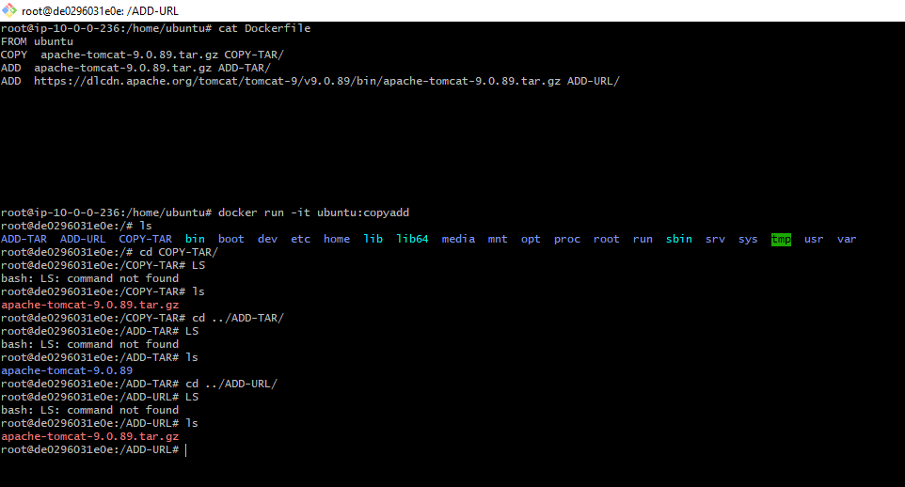

**Difference between attach and exec**

**Attach**:

* The **docker attach** command attaches your terminal to a running container, allowing you to view its output or interact with it directly through stdin/stdout/stderr.
* When you attach to a container, you connect to the process that's already running inside it, and you see its output directly in your terminal.
* It's useful for debugging or monitoring a container's output in real-time.

**Exec**:

* The **docker exec** command runs a new command in a running container, allowing you to execute arbitrary commands inside the container.
* When you use **docker exec**, you're creating a new process within the container, independent of any existing processes.
* It's useful for running commands inside a container without needing to start a new instance of the container, and it provides more flexibility for running various commands or scripts.

**Gothrough USER, LABEL,EXPOSE,SHELL,VOLUME**

**USER**: This command sets the username or UID (User ID) to use when running the image and for any subsequent commands that follow in the Dockerfile. It's often used to switch from the default "root" user to a less privileged user for security reasons.

**LABEL**: LABEL instruction adds metadata to an image. These are often key-value pairs that provide information about the image. This information could include version numbers, maintainer details, descriptions, etc. Labels are commonly used for organization and search purposes.

**EXPOSE**: This command informs Docker that the container listens on specific network ports at runtime. It does not actually publish the ports. It acts as documentation between the person who builds the image and the person who runs the container, stating which ports are intended to be published.

**SHELL**: The SHELL instruction allows the default shell used for the shell form of commands to be overridden. It's typically used to set the shell to be used in subsequent RUN instructions.

**VOLUME**: This command creates a mount point with the specified name and marks it as holding externally mounted volumes from native host or other containers. It is often used for persistent storage or to share data between containers or between the host and the container.

**Difference between EXPOSE & PUBLISH…**

**Expose**:

* The **EXPOSE** instruction in a Dockerfile informs Docker that the container listens on specific network ports at runtime. However, it doesn't actually publish these ports to the host machine's network interface.
* It acts as documentation between the person who builds the image and the person who runs the container, stating which ports are intended to be published.
* It's typically used for communication between containers or for internal networking within a Docker network.

**Publish**:

* The **docker run -p** or **docker run --publish** command is used to publish a container's ports to the host machine. This allows external processes to access the services running inside the container through those ports.
* When you publish a port, Docker creates a mapping between a port on the host machine and a port on the container.
* It's commonly used when you want to expose containerized services to the outside world or to other containers running on the same host.